Riphah International University Lahore, Pakistan

Riphah School of Computing & Innovation

Final Year Project
PROJECT REPORT

[Code Watch]

Project ID: [write ID here Issued by FYP Manager]

Project Team
Student Name | Student ID | Program | Contact Number | Email Address
Muhammad Ali Raza | 38622 | BSCS | 03242225073 | 38622@students.riphah.edu.pk

[Maam Zullatun Gul Khan]
(Lecturer)
Project Report
[Code Watch]

Change Record
Author(s) | Version | Date | Notes | Supervisor’s Signature
 | 1.0 |  | <Original Draft>
 |  |  | <Changes Based on Feedback from Supervisor>
 |  |  | <Changes Based on Feedback From Faculty>
 |  |  | <Added Project Plan>
 |  |  | <Changes Based on Feedback from Supervisor>

APPROVAL
PROJECT SUPERVISOR
Comments: ___________________________________________________________________
_____________________________________________________________________________
Name:______________________________
Date:_______________________________ | Signature:__________________________

PROJECT MANAGER
Comments: ___________________________________________________________________
_____________________________________________________________________________
Date:_______________________________ | Signature:__________________________

HEAD OF THE DEPARTMENT
Comments: ___________________________________________________________________
_____________________________________________________________________________
Date:_______________________________ | Signature:__________________________

Dedication

We dedicate our work to our parents, and teachers with heartfelt thanks for their constant support, guidance, and inspiration throughout this project. Their help has been invaluable, and we know that without their belief in us, we wouldn't have been able to embark on this journey of learning and growth. We are deeply grateful for their love, wisdom, and encouragement, and we will carry their lessons with us as we strive to do our best.

Acknowledgements

I am really thankful to my supervisor, Maam Zullatun Gul Khan, who has been a constant source of guidance, encouragement, and invaluable feedback throughout the development of the Code Watch project. Their expertise and continuous support helped me navigate the complex challenges of integrating machine learning models with web technologies and kept me focused on achieving the project's goals.
I would also like to express my sincere gratitude to the faculty and staff at the Riphah School of Computing & Innovation for providing an excellent academic foundation and the resources necessary to complete this endeavor.
Finally, I am deeply grateful to my family and friends for their unwavering moral support, patience, and understanding during the countless hours spent researching, coding, and training the AI models for this automated surveillance system.

Executive Summary
Modern security and surveillance systems traditionally rely on continuous human monitoring, a process that is highly susceptible to fatigue, oversight, and delayed response times. To address these critical inefficiencies, this project introduces "Code Watch," an advanced, AI-driven automated surveillance system designed to provide proactive, real-time security monitoring. The primary objective of Code Watch is to minimize the need for manual video observation by deploying intelligent algorithms capable of autonomous tracking, identification, and violation detection.
Code Watch leverages state-of-the-art computer vision technologies, specifically utilizing YOLO for object detection, to analyze live video feeds. The system's core AI pipeline is engineered to perform real-time people tracking and high-accuracy facial recognition. By maintaining a comprehensive data management system, Code Watch seamlessly cross-references faces in the video feed against a database of known individuals. This allows the system to instantly detect and flag unknown personnel entering restricted areas. Furthermore, the AI pipeline is trained to assess dress code compliance, adding an extra layer of policy enforcement to the surveillance environment.
From a technical standpoint, the project is built upon a modern, decoupled software architecture to ensure scalability and high performance. The user-facing frontend is developed using React, providing security administrators with a responsive and intuitive dashboard. Through this interface, users can manage the database, perform data entry to add new authorized personnel, and monitor live alerts. The backend is powered by Python and the Django REST Framework, which robustly handles the intensive processing requirements of the AI models, data routing, and API endpoints.
When a security breach or rule violation occurs—such as an unrecognized face or a dress code infraction—the system automatically tracks the targeted violator and locks their record in the database for future reference and auditing. This automated violation handling significantly enhances incident response times.
In conclusion, Code Watch successfully bridges the gap between passive video recording and active threat mitigation. By integrating facial recognition, behavioral tracking, and a decoupled web architecture, the project delivers a scalable, highly efficient surveillance solution that modernizes security protocols and drastically reduces the margin for human error.

Table of Contents
Dedication 4
Acknowledgements 5
Executive Summary 6
Table of Contents 8
List of Figures 11
List of Tables 12
Chapter 1 1
Introduction 1
1.1. Background 2
1.2. Motivations and Challenges 2
1.3. Goals and Objectives 2
1.4. Literature Review/Existing Solutions 2
1.5. Gap Analysis 2
1.6. Proposed Solution 2
1.7. Project Plan 3
1.7.1. Work Breakdown Structure 3
1.7.2. Roles & Responsibility Matrix 3
1.7.3. Gantt Chart 3
1.8. Report Outline 3
Chapter 2 4
Software Requirement Specifications 4
1.1. Introduction 5
1.1.1. Purpose 5
1.1.2. Document Conventions 5
1.1.3. Intended Audience and Reading Suggestions 5
1.1.4. Product Scope 5
1.1.5. References 6
1.2. Overall Description 6
1.2.1. Product Perspective 6
1.2.2. Product Functions 6
1.2.3. User Classes and Characteristics 6
1.2.4. Operating Environment 7
1.2.5. Design and Implementation Constraints 7
1.2.6. User Documentation 7
1.2.7. Assumptions and Dependencies 7
1.3. External Interface Requirements 8
1.3.1. User Interfaces 8
1.3.2. Hardware Interfaces 8
1.3.3. Software Interfaces 8
1.3.4. Communications Interfaces 9
1.4. System Features 9
1.4.1. System Feature 1 9
1.4.1.1. Description and Priority 9
1.4.1.2. Stimulus/Response Sequences 9
1.4.1.3. Functional Requirements 9
1.4.2. System Feature 2 10
1.4.2.1. Description and Priority 10
1.4.2.2. Stimulus/Response Sequences 10
1.4.2.3. Functional Requirements 10
1.4.3. System Feature 3 (and so on) 11
1.5. Other Nonfunctional Requirements 11
1.5.1. Performance Requirements 11
1.5.2. Safety Requirements 11
1.5.3. Security Requirements 12
1.5.4. Software Quality Attributes 12
1.5.5. Business Rules 12
1.6. Other Requirements 12
Chapter 3 13
Use Case Analysis 13
3.1. Use Case Model 14
3.2. Use Case Descriptions 14
Chapter 4 15
System Design 15
4.1. Architecture Diagram 16
4.2. Domain Model 16
4.3. Entity Relationship Diagram with data dictionary 16
4.4. Class Diagram 17
4.5. Sequence / Collaboration Diagram 17
4.6. Operation contracts 17
4.7. Activity Diagram 18
4.8. State Transition Diagram 18
4.9. Component Diagram 18
4.10. Deployment Diagram 19
4.11. Data Flow diagram [only if structured approach is used - Level 0 and 1] 19
Chapter 5 20
Implementation 20
5.1. Important Flow Control/Pseudo codes 21
5.2. Components, Libraries, Web Services and stubs 21
5.3. Deployment Environment 21
5.4. Tools and Techniques 22
5.5. Best Practices / Coding Standards 22
5.6. Version Control 22
Chapter 6 23
Testing and Evaluation 23
6.1. Use Case Testing 24
6.2. Equivalence partitioning 24
6.3. Boundary value analysis 24
6.4. Data flow testing 24
6.5. Unit testing 25
6.6. Integration testing 25
6.7. Performance testing 25
6.8. Stress Testing 25
Chapter 7 26
Summary, Conclusion and Future Enhancements 26
7.1. Project Summary 27
7.2. Achievements and Improvements 27
7.3. Critical Review 27
7.4. Lessons Learnt 27
7.5. Future Enhancements/Recommendations 28
Appendices 29
Appendix A: User Manual 30
Appendix B: Administrator Manual 31
Appendix C: Information / Promotional Material 32
Appendix [no.]: Appendix Title 34
Reference and Bibliography 35

List of Figures

1.1 Caption of first figure of first chapter 6
1.2 Caption of second figure of first chapter 7
2.1 Caption of first figure of second chapter 14
2.2 Caption of second figure of second chapter 22
2.3 Caption of third figure of second chapter 26
5.1 Caption of first figure of fifth chapter 49
5.2 Caption of second figure of fifth chapter 49

List of Tables

1.1 label of first table of first chapter 6
1.2 label of second table of first chapter 7
2.1 label of first table of second chapter 14
2.2 label of second table of second chapter 22
2.3 label of third table of second chapter 26
5.1 label of first table of fifth chapter 49
5.2 label of second table of fifth chapter 49

Chapter 1

Introduction

Chapter 1: Introduction
This chapter provides a comprehensive overview of the Code Watch project. It outlines the foundational concepts, primary motivations, and the core technical challenges the project seeks to address. Furthermore, it defines the specific goals and objectives, reviews existing surveillance solutions, identifies current system gaps, and details the proposed AI-driven architecture alongside the project execution plan.

Background
Surveillance systems have historically relied on passive video recording and continuous human monitoring to maintain security in private and public spaces. However, with rapid advancements in Artificial Intelligence (AI) and Computer Vision, the security paradigm is shifting from passive observation to active, automated threat detection. "Code Watch" emerges from this technological evolution as an intelligent, automated surveillance solution. By integrating a modern web architecture—utilizing a React frontend and a Python/Django REST Framework backend—the system deploys specialized AI pipelines to perform real-time people tracking, facial recognition, and dress code assessment. This automated approach aims to enhance modern security protocols by instantly cross-referencing individuals with a registered database, thereby identifying unknown entities and logging rule violations without the need for constant human intervention.

Motivations and Challenges
The primary motivation behind Code Watch is to eliminate the critical inefficiencies and human errors associated with manual video surveillance. Human operators are naturally prone to fatigue and distraction, which often leads to delayed responses to security breaches. By automating the detection of unauthorized personnel and dress code violators, this project seeks to provide a proactive security measure that instantly tracks and locks targeted violators in a database for immediate action and future auditing.
Despite these strong motivations, developing this system presents several notable challenges:
- Real-Time Processing Latency: Analyzing live video feeds for object detection and facial recognition requires highly optimized AI models and robust backend processing to minimize lag.
- Environmental Variability: Achieving high accuracy in facial recognition and dress code detection is inherently difficult under diverse lighting, angles, and environmental conditions.
- Architectural Complexity: Establishing a seamless, decoupled architecture between the React frontend and the Python/Django backend to handle continuous video data streams, data entry, and instant alerting poses a significant software engineering challenge.

Goals and Objectives
The primary goal of the Code Watch project is to develop an intelligent, automated surveillance system that minimizes the need for human monitoring while maximizing security responsiveness. To achieve this overarching goal, the project targets the following specific objectives:
- To implement a robust computer vision pipeline capable of real-time people detection and tracking within a live video feed.
- To integrate a highly accurate facial recognition module that cross-references detected faces against a secure database of known individuals, instantly flagging unauthorized or unknown persons.
- To develop and incorporate a specialized AI model for assessing dress code compliance, ensuring targeted organizational rules are enforced.
- To construct a scalable, decoupled software architecture utilizing a React-based frontend and a Python/Django backend to manage system data, user entry, and real-time alerts efficiently.
- To create an automated violation handling system that logs, tracks, and locks targeted violators in the database for post-incident review and auditing.

Literature Review/Existing Solutions
The landscape of security and surveillance has evolved significantly from traditional closed-circuit television (CCTV) systems. Early solutions relied entirely on passive video recording, which provided forensic value after an incident but offered no real-time preventative capabilities. More recent developments have introduced "smart" camera systems equipped with basic motion detection and rudimentary facial recognition. Enterprise-level solutions, such as those provided by major security vendors, incorporate advanced analytics; however, they are often heavily localized, proprietary, and require expensive, specialized hardware. While current literature highlights the efficacy of Convolutional Neural Networks (CNNs) and real-time object detection models like YOLO for tracking and classification, many commercial systems still treat facial recognition and behavioral or attribute classification (such as dress code) as completely separate, disconnected modules rather than a unified pipeline.

Gap Analysis
A critical analysis of existing surveillance solutions reveals several distinct gaps that Code Watch aims to address. First, there is a significant lack of accessible, unified systems that combine identity verification (facial recognition) with attribute enforcement (dress code compliance) in a single, automated real-time pipeline. Most existing systems alert human operators to motion but still require the operator to visually verify the individual's identity and attire, leaving a gap in true automation. Second, enterprise solutions are typically tightly coupled, making them rigid and difficult to integrate with modern web-based administrative dashboards. Code Watch bridges this architectural gap by utilizing a decoupled React and Django REST Framework architecture, providing a highly flexible and accessible data management and entry system. Finally, there is a gap in automated targeted tracking; Code Watch specifically addresses this by automatically locking confirmed violators into the database for future reference, shifting the system from merely an alerting tool to an active database-driven tracking mechanism.

Proposed Solution
To effectively address the limitations of existing systems, the proposed solution is "Code Watch," a comprehensive, AI-driven surveillance application. The system utilizes a decoupled architecture, leveraging a React-based frontend to provide a highly responsive, user-friendly administrative dashboard. The backend, built with Python and the Django REST Framework, handles complex data routing, API management, and the execution of the core AI pipeline. This computer vision pipeline continuously processes video frames to perform real-time people tracking, facial recognition against a secure database, and dress code violation detection. By automating both the identification and the rule enforcement processes, Code Watch provides security personnel with instant alerts and automatically logs targeted violators, ensuring a proactive and highly efficient security environment.

Project Plan
The development of Code Watch is executed through a structured project management approach to ensure all milestones are met within the academic timeline. The plan encompasses requirement gathering, system design, model training, software development, and rigorous testing phases.

Work Breakdown Structure
The Work Breakdown Structure (WBS) divides the Code Watch project into manageable, logical components:
- Phase 1: Research and Requirements: Literature review, defining system scope, and finalizing the Software Requirement Specifications (SRS).
- Phase 2: System Design: Creating architectural diagrams, database schemas, and API endpoint definitions for the decoupled Django/React setup.
- Phase 3: AI Development: Gathering datasets, training the facial recognition models, and configuring the object detection (YOLO) pipeline for tracking and dress code analysis.
- Phase 4: Software Implementation: Developing the Python/Django backend, building the React frontend dashboard, and integrating the AI pipeline.
- Phase 5: Testing and Deployment: Conducting unit testing, integration testing, system optimization for latency reduction, and final deployment.

Roles & Responsibility Matrix
As this project is being developed individually, all technical and administrative responsibilities are managed by a single student, with oversight and guidance provided by the project supervisor.

Team Member | Primary Role | Key Responsibilities
Syed Muhammad Ali Raza | Lead Developer / AI Engineer | Backend architecture (Django REST), AI pipeline integration (Python, OpenCV), Model training, Frontend development (React), API integration, UI/UX design, System Testing, and Project Documentation.
Maam Zullatun Gul Khan | Project Supervisor | Academic guidance, progress evaluation, technical mentorship, and final project approval.

Gantt Chart
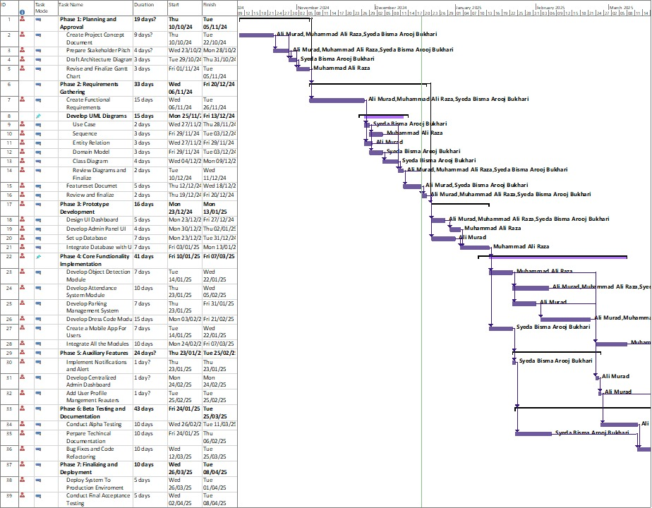

Report Outline
The remainder of this document is organized as follows:
- Chapter 2: Software Requirement Specifications: Details the product scope, functional and non-functional requirements, and system features.
- Chapter 3: Use Case Analysis: Provides use case models and descriptions illustrating user interactions with the system.
- Chapter 4: System Design: Presents the architectural, structural, and behavioral diagrams that form the blueprint of the application.
- Chapter 5: Implementation: Discusses the deployment environment, technologies, libraries, and coding standards used during development.
- Chapter 6: Testing and Evaluation: Outlines the methodologies used to verify system performance, including unit, integration, and stress testing.
- Chapter 7: Summary, Conclusion, and Future Enhancements: Concludes the report with a critical review, lessons learned, and recommendations for future system upgrades.

Chapter 2

Software Requirement Specifications

Chapter 2: Software Requirement Specifications

Introduction

Purpose
The purpose of the Code Watch system is to provide an intelligent, AI-driven automated surveillance solution that significantly enhances organizational security and operational efficiency. By integrating advanced computer vision and deep learning models with existing Video Management Systems (VMS), Code Watch aims to replace manual, error-prone human monitoring with real-time, proactive threat detection. The system is specifically designed to automate critical security tasks, including identifying individuals through facial recognition, tracking attendance securely, instantly detecting unauthorized or unknown personnel, and enforcing organizational policies through real-time dress code compliance monitoring. Ultimately, Code Watch serves to create a highly responsive and secure environment by delivering instant alerts and providing administrators with a centralized web and mobile management dashboard.

Document Conventions
This document adheres to the standard typographical and formatting guidelines provided by the Riphah School of Computing & Innovation , utilizing 12-point Calibri font, justified alignment, and 1.5 line spacing for all main paragraph text.
To ensure clarity and traceability, the following conventions are observed throughout this SRS:
- Requirement Numbering: Every specific functional requirement is uniquely identified with a designated tag (e.g., REQ-SF1-1, representing System Feature 1, Requirement 1).
- Priority Inheritance: Priorities (High, Medium, Low) assigned to higher-level system features are assumed to be inherited by all their detailed sub-requirements unless explicitly stated otherwise.
- Terminology: The term "System" refers exclusively to the Code Watch application. The terms "Admin" or "Administrator" refer to the authorized security personnel managing the system.

Intended Audience and Reading Suggestions
This SRS document is intended for a diverse audience involved in the evaluation and deployment of the Code Watch system.
- Academic Evaluators and Supervisor: To assess the scope, feasibility, and technical depth of the Final Year Project.
- Developers: To serve as the definitive blueprint for coding the React frontend, Django backend, and the Python-based AI pipeline.
- Security Administrators: To understand the operational capabilities, such as accessing the centralized dashboard and receiving real-time alerts. It is recommended that readers begin with the Overall Description (Section 2.2) to understand the system's broad context before examining the highly technical System Features (Section 2.4).

Product Scope
Code Watch is a comprehensive software solution that integrates advanced technologies—specifically deep learning, computer vision, and facial recognition—with existing Video Management Systems (VMS). The system automates essential security and management tasks by shifting from passive video recording to active threat and compliance detection. The scope of the project encompasses an AI pipeline that identifies individuals for secure attendance tracking, monitors adherence to organizational dress codes, and detects unauthorized or unknown persons. Furthermore, it features a centralized web dashboard and a mobile application for administrators, enabling real-time notifications and centralized security management.

References
- IEEE Recommended Practice for Software Requirements Specifications (IEEE Std 830-1998).
- Documentation for the React JavaScript Library (Frontend UI).
- Django REST Framework Official Documentation (Backend API and Routing).
- OpenCV and YOLOv8 Documentation (Computer Vision and Object Detection).
- PyTorch/TensorFlow Documentation (Facial Recognition and Deep Learning Models).

Overall Description

Product Perspective
Code Watch is a new, self-contained automated surveillance and management system designed to modernize traditional security monitoring. It operates as an independent platform that integrates directly with existing campus or organizational Video Management System (VMS) cameras to capture live footage. From an architectural standpoint, the system utilizes a modern, decoupled approach. The backend is powered by Python and the Django REST Framework to handle data routing and intensive deep-learning AI model inference (using YOLO and OpenCV). The presentation layer consists of a React-based centralized web dashboard and a cross-platform mobile application, ensuring administrators have flexible, real-time access to security data.

Product Functions
The system is designed to automate critical surveillance tasks to improve organizational safety and efficiency. The major functions include:
+1
- Face Authentication & Tracking: Users (students and staff) are authenticated using facial recognition for secure and accurate attendance tracking and identity verification.
- Unauthorized Personnel Detection: The system continuously cross-references detected faces with the database to immediately flag unknown or blacklisted individuals.
- Dress Code Monitoring: The system leverages computer vision to monitor and alert administrators when organizational dress code violations are detected via the integrated cameras.
- Real-Time Alerts: The system generates and dispatches real-time notifications for security incidents, attendance breaches, and policy violations, keeping administrators informed instantly.
- Centralized Dashboard: Administrators can manage database records, view surveillance analytics, and handle alerts from a unified web interface.

User Classes and Characteristics
The system anticipates two primary classes of users:
- Administrators / Security Personnel (High Priority): This user class has full access privileges. They utilize the React dashboard and mobile app to manage user records, integrate external cameras, monitor real-time alerts, and generate analytics reports. They require a highly responsive interface for immediate decision-making during security events.
- General Users (Students / Faculty): This user class interacts with the system primarily passively (e.g., walking past a camera for facial recognition attendance). They may also use the application with limited privileges to view their own attendance records or receive specific notifications.

Operating Environment
Code Watch is designed to operate in a distributed client-server environment:
- Backend Server: Requires a robust environment running Python and Django, with sufficient computational hardware (ideally GPU-accelerated) to process deep learning models (PyTorch/TensorFlow) and computer vision tasks without high latency.
- Client (Web): The React-based dashboard is accessible via modern web browsers (e.g., Google Chrome, Mozilla Firefox, Microsoft Edge).
- Client (Mobile): The mobile application is accessible on both iOS and Android operating systems to ensure seamless cross-platform functionality.
- Hardware Integration: Relies on standard IP cameras or existing VMS infrastructure for real-time video input.

Design and Implementation Constraints
The development and deployment of the system are limited by several constraints:
- Hardware Limitations: Real-time AI processing requires significant computational power; slow server hardware will introduce latency in video processing and alerting.
- Environmental Factors: The accuracy of facial recognition and dress code monitoring is highly constrained by the quality of the camera feed, lighting conditions, and camera angles.
- Privacy and Security: The system must strictly adhere to data privacy regulations regarding the storage and processing of sensitive biometric data (facial features), necessitating robust encryption and role-based access controls.

User Documentation
To ensure smooth deployment and operation, the software will be delivered with a comprehensive User Manual (Appendix A) for general users and an Administrator Manual (Appendix B) detailing system configuration, camera integration, and database management.

Assumptions and Dependencies
The successful operation of Code Watch relies on the following factors:
- Assumptions: It is assumed that the physical environment will have adequate lighting for the AI models to extract features accurately. It is also assumed that all authorized personnel are pre-registered in the database with high-quality reference images.
- Dependencies: The system is completely dependent on continuous, high-speed network connectivity to transmit video feeds to the backend and push real-time alerts to the frontend. It also depends on the uptime and reliability of the external camera hardware.

External Interface Requirements

User Interfaces
The primary interface for administrators. It features a responsive grid layout. The main view consists of a live video feed panel, a real-time alert ticker on the side, and a navigation menu to access different modules (User Management, Analytics, Settings). Standard GUI components such as standard buttons, search bars, and paginated data tables are used for managing the database. Error messages and success notifications will be displayed via standardized pop-up toast notifications.
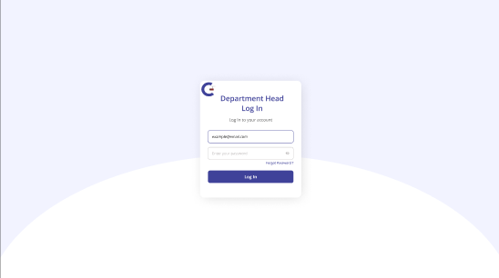
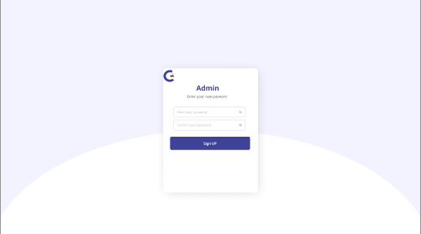
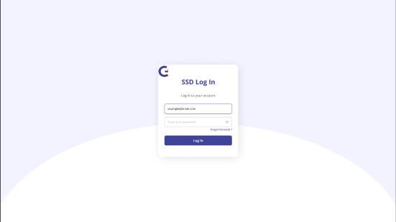
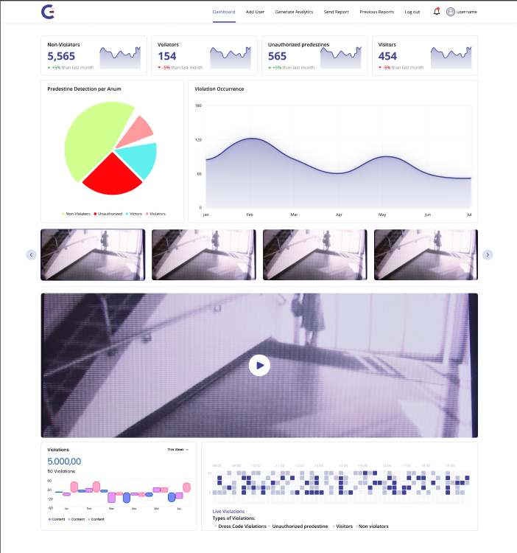

Hardware Interfaces
Code Watch relies on specific hardware interactions to function effectively:
- Camera Systems (VMS / IP Cameras): The software interfaces with external IP cameras or existing Video Management Systems to receive continuous video streams.
- Processing Server: The backend system interfaces with the host server's CPU and GPU (Graphics Processing Unit). High-performance GPU hardware is critical for executing the deep learning models (YOLO and facial recognition algorithms) with low latency.
- Networking Hardware: Standard Network Interface Cards (NICs) are required to handle the high bandwidth of incoming video streams and outgoing API responses.

Software Interfaces
The system's decoupled architecture involves several critical software interfaces:
- Frontend-Backend Interface: The React.js frontend communicates with the Python/Django backend via RESTful APIs. The backend exposes specific endpoints (e.g., /api/users/, /api/alerts/) to serve JSON data to the frontend.
- Database Management System (DBMS): The Django backend interfaces with a relational database (e.g., PostgreSQL or MySQL) to store user profiles, violation logs, and system settings.
- Computer Vision & AI Libraries: The Python backend directly interfaces with the OpenCV library for frame extraction and image processing. It also interfaces with PyTorch/TensorFlow to run the YOLO object detection and facial recognition models.
- Operating System: The backend server software is designed to run on standard Linux or Windows Server operating systems.

Communications Interfaces
To ensure real-time data flow and security, the system utilizes the following communication protocols:
- HTTP/HTTPS: All API communications between the web/mobile clients and the Django REST Framework backend occur over HTTPS to ensure data encryption and security.
- RTSP (Real-Time Streaming Protocol): The system uses RTSP to fetch live video feeds from the connected IP cameras directly into the backend processing pipeline.
- WebSockets: To achieve real-time alerting without requiring the user to refresh the dashboard, WebSockets are utilized to push violation notifications from the server to the client instantly.

System Features
<This template illustrates organizing the functional requirements for the product by system features, the major services provided by the product. You may prefer to organize this section by use case, mode of operation, user class, object class, functional hierarchy, or combinations of these, whatever makes the most logical sense for your product.>

Automated Facial Recognition and Tracking

Description and Priority
This feature is the core of the Code Watch system. It utilizes computer vision and deep learning to identify individuals appearing in the live video feed. By cross-referencing detected faces against a registered database, the system automatically logs attendance for known users and instantly flags unknown or blacklisted individuals. Priority: High.

Stimulus/Response Sequences
- Stimulus: A person enters the frame of a connected camera.
- Response: The system detects the person, extracts facial features, and queries the database.
- Stimulus: The face matches a registered user.
- Response: The system logs the user's attendance with a timestamp and location.
- Stimulus: The face does not match any registered user (Unknown) or matches a blacklisted user.
- Response: The system generates an immediate alert and begins tracking the individual across frames.

Functional Requirements
- REQ-SF1-1: The system shall accurately detect human faces within a live video stream (minimum 15 FPS) under standard lighting conditions.
- REQ-SF1-2: The system shall extract facial embeddings and compare them against the database in real-time.
- REQ-SF1-3: The system shall automatically record the attendance (check-in/check-out time) of positively identified registered users.
- REQ-SF1-4: The system shall identify and flag individuals whose facial features do not match any active user profile as "Unknown".
- REQ-SF1-5: The system shall allow administrators to manually review, add, or update user profiles and their corresponding reference images via the dashboard.

Real-Time Dress Code Monitoring

Description and Priority
This feature enforces organizational policies by autonomously analyzing the attire of detected individuals. Using a specialized object detection model (e.g., YOLO), the system identifies specific clothing items and flags instances of non-compliance. Priority: Medium.

Stimulus/Response Sequences
- Stimulus: A person is detected in the video feed.
- Response: The system analyzes the individual's bounding box for specific clothing attributes.
- Stimulus: The detected clothing violates predefined organizational rules (e.g., wearing shorts instead of trousers).
- Response: The system flags the individual, captures a snapshot of the violation, and logs the event in the database.

Functional Requirements
- REQ-SF2-1: The system shall process video frames to classify the clothing worn by detected individuals.
- REQ-SF2-2: The system shall determine if the classified clothing violates the currently active dress code policy configured by the administrator.
- REQ-SF2-3: The system shall capture a high-resolution snapshot of the individual at the moment the violation is detected.
- REQ-SF2-4: If the violator's face is recognized (per REQ-SF1), the system shall automatically link the dress code violation to their specific user profile.
- REQ-SF2-5: The system shall allow administrators to toggle the dress code monitoring feature on or off via the settings dashboard.

Real-Time Alert Generation and Violation Logging

Description and Priority
This feature ensures that administrators are immediately notified of any security or policy breaches. It handles the routing of alerts to the web dashboard and mobile application, and maintains a secure audit log of all incidents. Priority: High.

Stimulus/Response Sequences
- Stimulus: The AI pipeline detects an unknown person (REQ-SF1-4) or a dress code violation (REQ-SF2-2).
- Response: The backend generates an alert payload containing the timestamp, location, snapshot, and violator ID (if known).
- Stimulus: The alert payload is ready.
- Response: The system pushes the alert to the web dashboard (via WebSockets) and to the mobile application (via push notifications).
- Stimulus: An administrator clicks "Acknowledge" or "Review" on the alert.
- Response: The system updates the status of the violation log in the database.

Functional Requirements
- REQ-SF3-1: The system shall automatically generate an alert whenever an unknown individual, blacklisted individual, or policy violation is detected.
- REQ-SF3-2: The system shall push alerts to connected web clients in real-time (under 2 seconds latency).
- REQ-SF3-3: The system shall send push notifications to authenticated mobile application users.
- REQ-SF3-4: The system shall maintain a persistent log of all alerts in the database, accessible via the dashboard for historical review and analytics.
- REQ-SF3-5: The system shall allow administrators to update the status of an alert (e.g., "Pending," "Reviewed," "Resolved").

Other Nonfunctional Requirements

Performance Requirements
To provide effective real-time surveillance, the system must meet strict performance benchmarks:
- Processing Speed: The AI pipeline (facial recognition and object detection) must process live video streams at a minimum of 15 frames per second (FPS) to ensure targets are accurately tracked without significant lag.
- Alert Latency: Upon detecting a violation or unknown individual, the backend must generate and push the alert to the React web dashboard and mobile application within 2 seconds.
- API Response Time: General REST API endpoints (e.g., fetching user data or alert history) should respond in under 500 milliseconds under normal load.

Safety Requirements
While Code Watch is a software application, its role in physical security mandates certain safety-critical behaviors:
- Camera Feed Failure: If the connection to an integrated VMS camera is lost, the system must immediately alert the administrator of the blind spot.
- Data Integrity: In the event of a sudden power loss or server crash, the system must employ transaction-safe database operations to prevent the corruption of violation logs and attendance records.

Security Requirements
Given the sensitive nature of biometric surveillance, robust security measures are paramount:
- Data Encryption: All sensitive data, particularly facial embeddings and user passwords, must be safeguarded with strong encryption. Network communications between the frontend clients and the Django backend must occur over HTTPS.
- Access Control: The system must implement strict role-based access controls. Only authorized administrators may view live camera feeds, manage the user database, or configure dress code policies.
- Compliance: Mechanisms must be implemented to ensure the handling of biometric data complies with relevant data protection regulations and organizational privacy policies.

Software Quality Attributes
Scalability: The system architecture must be designed to accommodate the growing needs of the organization, allowing for the seamless integration of additional cameras and the expansion of the user database without severe performance degradation.
Usability: The React-based centralized dashboard must focus on a user-friendly interface to ensure seamless interaction by all users, allowing security personnel to navigate alerts and records intuitively without requiring extensive technical training.
Reliability: The backend surveillance pipeline must be designed for continuous, 24/7 operation with automated error-handling to recover from minor software faults without dropping the video feed.

Business Rules
The system logic is guided by the following operational principles:
- Rule 1 (Authorization): Only registered security personnel with "Admin" privileges can add, update, or remove individuals from the facial recognition database.
- Rule 2 (Policy Configuration): The specific parameters for dress code monitoring (e.g., allowing or disallowing specific clothing items) can only be altered by a super-administrator.
- Rule 3 (Alert Resolution): A generated violation alert remains in a "Pending" or "Active" state until a security administrator explicitly acknowledges or resolves it through the dashboard.

Other Requirements
Database Requirements: The system requires a robust relational database management system (e.g., PostgreSQL) to handle complex queries related to user attendance and violation histories efficiently. It also requires scalable, secure file storage for retaining high-resolution snapshots of detected violations.

Chapter 3

Use Case Analysis

Chapter 3: System Analysis
In this chapter, we dive deep into analyzing the Code Watch automated surveillance system. This section provides a visual and descriptive overview of how different actors (such as administrators, general users, and the system itself) interact to achieve specific goals. It defines exactly what the system does inside its boundaries, covering all its features and functionalities, such as how attendance management integrates with security systems and how dress code monitoring triggers automated alerts .

Use Case Model
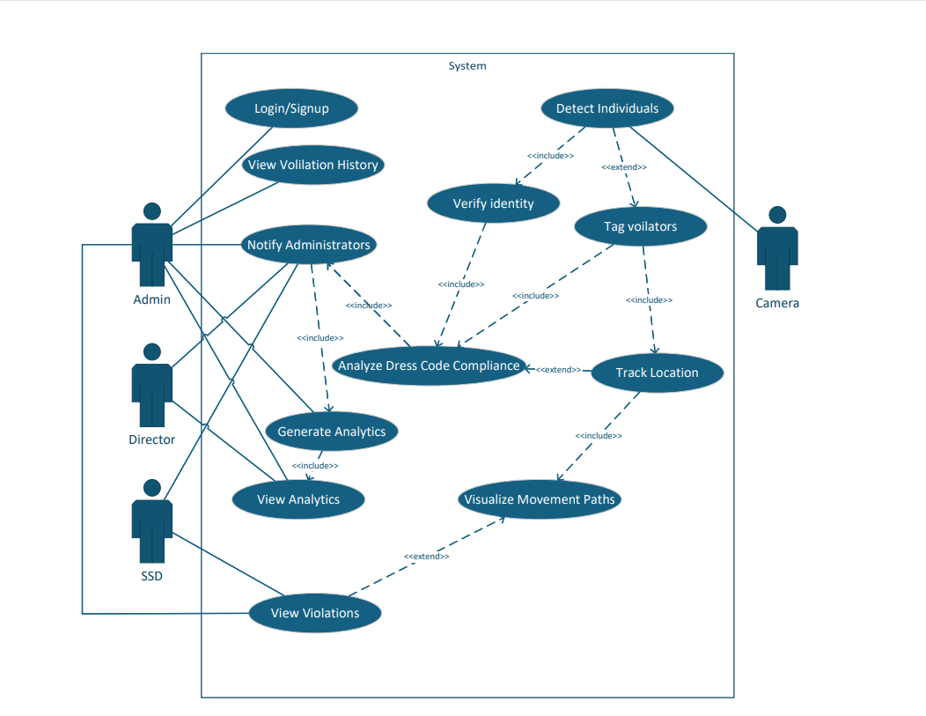

Use Case Descriptions

No. | Use Case | Description | Primary Actor(s) | Goal | Pre-Condition | Post-Condition | Trigger | Scenario
1 | Login / Signup | Allows organizational personnel to access the system securely. | Admin, Director, SSD | Authenticate users and grant them role-based access to the dashboard. | The user must have registered credentials in the database. | The user is granted access to view analytics, violations, or manage settings based on their role. | The user navigates to the system portal and enters credentials. | - The user navigates to the login page.  - The user enters their username and password.  - The system validates the credentials against the database.  - The system grants access and redirects the user to their specific dashboard view.  - If the credentials are invalid, an error message is displayed.
2 | Detect Individuals (includes Verify Identity) | This use case starts when the system captures video frames, identifies human presence, and subsequently extracts facial features to verify identity. | Camera | Automatically detect people and cross-reference their facial embeddings with the known database. | - The camera feed is active and transmitting.  - The AI processing pipeline (YOLO/FaceNet) is running. | The individual is either verified as a known entity (attendance logged) or flagged for further analysis as "Unknown". | A person walks into the camera's field of view. | 1. The camera captures the video feed containing the person.  2. The AI pipeline detects the human figure.  3. The system extracts the facial features and queries the database (Verify Identity).  4. The system logs the identity if known, or assigns a temporary tracking ID if unknown.
3 | Tag Violators (extends Detect Individuals) | If an individual is flagged during detection (e.g., unknown person or policy breach), the system tags them as a violator. This includes analyzing their dress code compliance and tracking their location. | System / Camera | Classify the nature of the violation (e.g., Dress Code) and begin tracking the target across camera feeds. | An individual is detected, and criteria for a violation are met (e.g., face not recognized, or specific clothing detected). | The violator is tagged, their movement is tracked, and an alert payload is formulated. | The AI pipeline flags an anomaly during the "Detect Individuals" process. | 1. The base use case "Detect Individuals" executes and flags a subject.  2. The system triggers "Tag Violators".  3. The system executes "Analyze Dress Code Compliance" to check attire against policy.  4. The system executes "Track Location" to follow the violator's bounding box across frames.  5. The system logs the violation event.
4 | Notify Administrators | This use case starts when the system pushes real-time alerts to the administrative staff after a violation is confirmed. | Admin, Director, SSD | Ensure security personnel are immediately aware of policy or security breaches. | "Analyze Dress Code Compliance" or "Tag Violators" has successfully identified and logged a breach. | An alert (with snapshot and location) is sent to the dashboard and mobile app. | The completion of the compliance analysis triggers the notification pipeline. | 1. The system identifies a critical event (e.g., dress code violation, unknown face).  2. The system formats the alert payload.  3. The system sends the alert via WebSockets/Push Notifications to the authorized roles.  4. The system logs the notification delivery status.
5 | View Violations (extends to Visualize Movement Paths) | This use case starts when authorized staff review logged violations. Users can extend this action to visualize the specific movement paths of the tracked violator. | Admin, Director, SSD | Review security logs, acknowledge alerts, and optionally understand the trajectory of a violator through the premises. | - The user is logged in.  - Violations exist in the database. | The user successfully views the violation details and updates their status. | The user clicks on a specific violation log from their dashboard. | 1. The user selects the "View Violations" option.  2. The system retrieves the list of logged incidents.  3. The user selects a specific violation to view details (snapshot, time, location).  4. Optionally, the user triggers "Visualize Movement Paths" to see the tracked route.  5. The user acknowledges or resolves the violation.
6 | View Analytics (includes Generate Analytics) | This use case provides staff with comprehensive reports and charts summarizing system activity, attendance, and violation trends. | Admin, Director, | Provide high-level insights for management and security review. | The user is logged in.  The system has collected sufficient historical data. | The system computes the data and renders the charts on the user's screen. | The system computes the data and renders the charts on the user's screen. | 1. The user selects the "Analytics" option.  2. The system triggers "Generate Analytics" to compute current statistics (e.g., total violations this week).  3. The system displays graphs and reports.  4. The user interacts with the data (e.g., applies date filters).

Chapter 4

System Design

Chapter 4: System Design
This chapter focuses on the System Design phase of the Software Development Life Cycle (SDLC) for the Code Watch project. Designing the software marks the initial step in shifting from identifying problems and requirements to devising technical solutions. During this phase, the system's architecture, structural boundaries, and data management strategies are refined into a suitable format, aiding the developer in building and integrating the AI pipeline, backend APIs, and frontend dashboard.

Architecture Diagram
The Code Watch system is built upon a modular, service-oriented architecture designed to handle real-time surveillance and complex AI processing. As illustrated in Figure 21, the architecture is divided into distinct functional blocks that interact seamlessly to deliver the system's capabilities.
- User Interfaces & Core System
The primary point of interaction is the Admin Dashboard (React frontend), which communicates with the backend via the API Gateway. The Core System handles the routing of these requests to specialized microservices:
- User Management Service: Handles administrator actions such as adding, updating, or deleting user profiles and managing access control.
- Violation Detection Service: The active surveillance engine. It utilizes the trained AI models to analyze live feeds, detect unauthorized personnel, and monitor dress code compliance.

- Model Training Pipeline
A distinct component of the architecture is dedicated to the AI's continuous improvement.
- The Model Training System handles Image Processing and the actual training of the Computer Vision Model (using YOLO and OpenCV).
- The pipeline outputs Evaluation Metrics and produces the final Trained Model For Detection, which is then deployed into the Data Storage layer for active use by the Core System.

- Data Storage
This layer serves as the centralized repository for all system data, ensuring data integrity and fast retrieval:
- User Database: Stores personnel records, credentials, and facial embeddings.
- Violation Database: Stores logs of all detected incidents, including timestamps and snapshot evidence.
- Training Dataset Storage: Holds the raw images and annotated data required for the Model Training System.
- Trained Model For Detection: The operational AI model weights stored for inference by the Core System.

- Alerts and Notifications
When the Violation Detection Service flags an incident, it triggers the Notification Service. This service acts as a dispatcher, routing alerts through various channels:
- Admin Alerts: Push notifications or WebSocket alerts sent directly to the Admin Dashboard.
- Email Service & SMS Gateway: Used to send formal warnings or automated SMS to Violators.

- Analytics and Reporting
The Analytics Service aggregates data from the Violation Database to generate high-level insights. It produces structured Reports and visualizes Violation Trends Analytics, allowing administrators to review security performance over time.
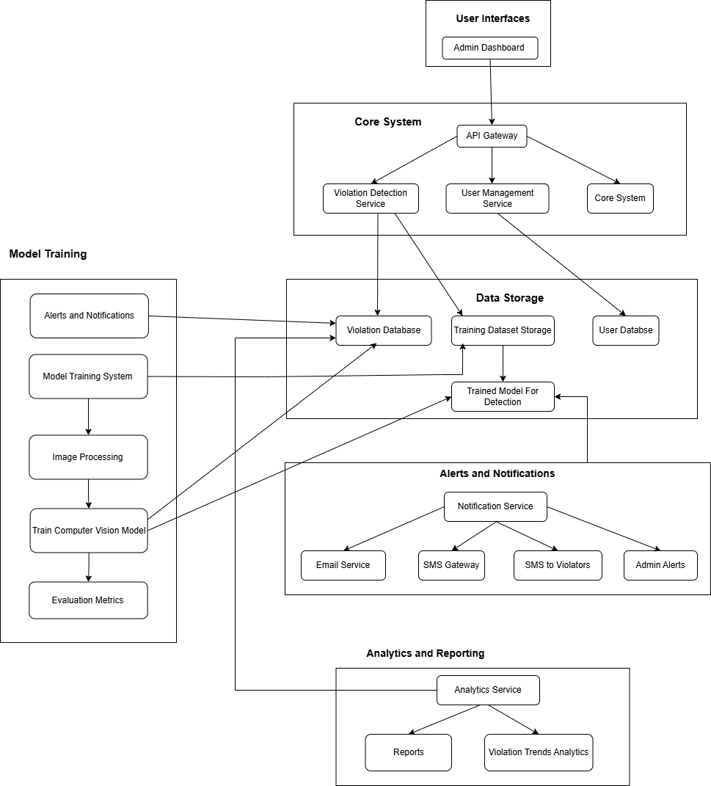

Entity Relationship Diagram with data dictionary
The Entity Relationship Diagram (ERD) defines the logical structure of the Code Watch database, optimized for real-time tracking and relational data integrity. As illustrated, the schema revolves around the central Violations table, which connects the tracking, administrative, and notification components.

Key Entities and Data Dictionary:
- User Table: Manages system administrators and their access levels.
  - Attributes: user_id (PK), name, email, username, password, Role, CreatedAt, UpdatedAt.
- Individuals Table: Stores the biometric and demographic data of known persons.
  - Attributes: individual_id (PK), name, gender, UniqueId, ImagePath (reference image for AI extraction), CreatedAt, UpdatedAt.
- Cameras Table: Stores the configuration and geographical data of the integrated video sources.
  - Attributes: camera_id (PK), camera_name, LocationLatitude, LocationLongitude, Coverage_areas, CreatedAt, updatedAt.
- dressCodeRules Table: Defines the dynamic policies enforced by the AI pipeline.
  - Attributes: rule_id (PK), Gender, AllowedClothingItems, CreatedBy (FK to User), createdAt, updatedAt.
- Violations Table: The central junction table recording all detected incidents.
  - Attributes: violation_id (PK), individual_id (FK to Individuals, nullable for unknowns), camera_id (FK to Cameras), rule_id (FK to dressCodeRules), Violation_type, TimeStamp, LocationLatitude, LocationLongitude, isResolved.
- MovementTracking Table: Logs the location of detected individuals over time to map their trajectory across the premises.
  - Attributes: tracking_id (PK), individual_id (FK to Individuals), camera_id (FK to Cameras), LocationLatitude, LocationLongitude, TimeStamp, CreatedAt.
- ViolationHistory Table: Maintains an audit trail of actions taken by administrators regarding a specific violation.
  - Attributes: history_id (PK), violation_id (FK to Violations), action_taken, resolve_by (FK to User), Resolution_notes, Timestamp, createdAt.
- Notifications & SMSAlerts Tables: Manage the dispatch of real-time alerts.
  - Notifications Attributes: notification_id (PK), violation_id (FK), sent_to, Message, isRead, CreatedAt.
  - SMSAlerts Attributes: Alert_id (PK), violation_id (FK), sent_to, Message, phoneNumber, sent_At, CreatedAt.
- Analytics Table: Stores pre-computed data aggregations for the dashboard.
  - Attributes: analytics_id (PK), violation_id (FK), time_period, Gender_basedAnalysis, Location_basedAnalysis, CreatedAt

Relationships:

The ERD demonstrates complex interconnectivity: a single User can create multiple dressCodeRules and resolve multiple ViolationHistory records. A single Individual can trigger multiple Violations and generate numerous MovementTracking logs. The central Violations record serves as the foreign key for generating Notifications, SMSAlerts, ViolationHistory, and Analytics entries.

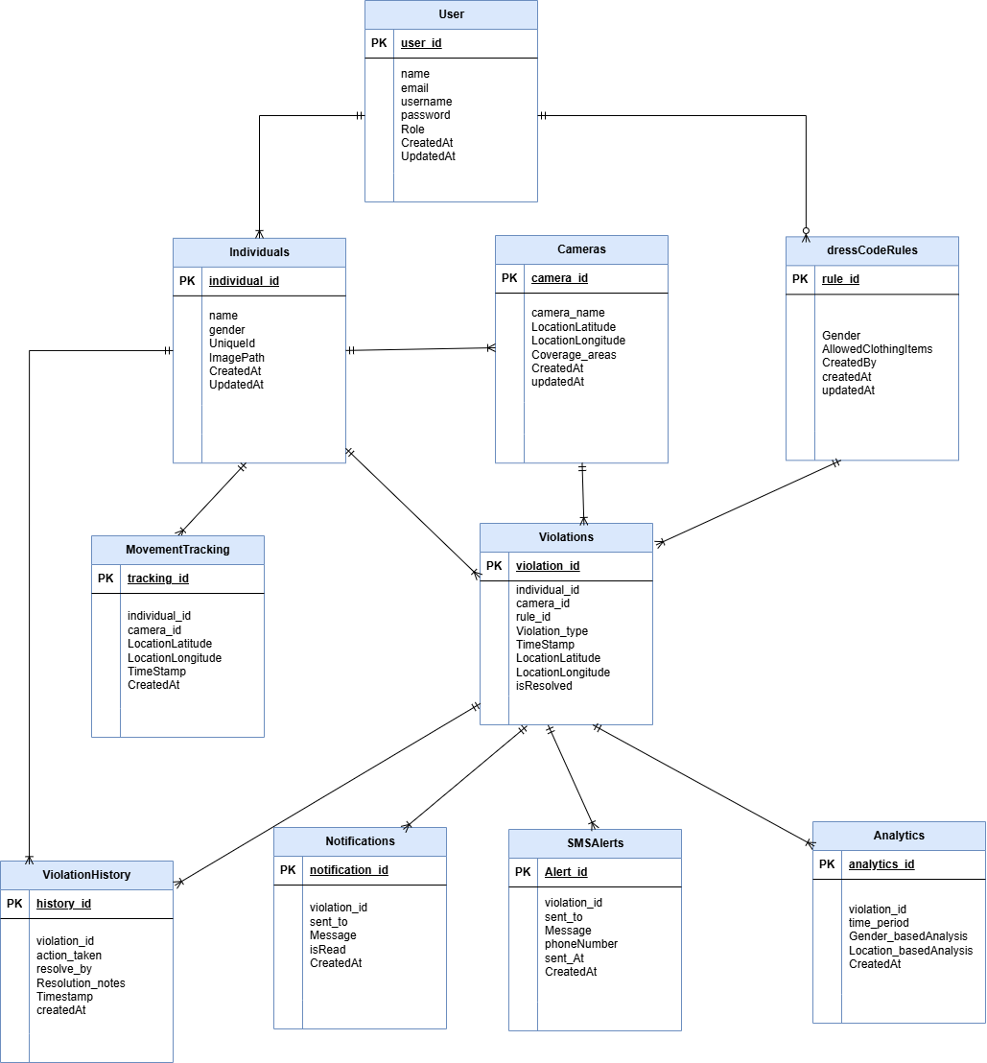

Class Diagram
The Class Diagram provides a static structural view of the Code Watch system. It illustrates the primary classes that make up the system, detailing their data attributes, functional operations (methods), and the multiplicities of their relationships. This diagram serves as the direct blueprint for implementing the object-oriented structure within the Django backend.

Core Classes and Operations:
- User: Represents the administrators accessing the system. It contains authentication attributes (username, password, Role) and key administrative methods such as createRule() and resolveViolation().
- Individual: Represents the tracked personnel, storing their demographic data and biometric reference (ImagePath). It includes the getViolations() method to retrieve a specific individual's incident history.
- Camera: Represents the physical video sources. It stores geographical data (LocationLatitude, LocationLongitude) and executes the critical captureViolations() method to interface with the AI pipeline.
- DressCodeRule: Encapsulates the configurable policies. It stores the AllowedClothingItems for a specific Gender and contains the applyRule() operation to enforce these parameters against detected individuals.
- Violation: The central class representing an incident. It aggregates data from the Camera, Individual, and DressCodeRule classes. It contains the primary logViolation() method to record the event timestamp and location.
- Supporting Action Classes:
  - MovementTracking: Tracks the Individual across cameras via the tractMovement() method.
  - Notification & SMSAlerts: Handle dispatching alerts via sendNotification() and sendSMS() methods, respectively, triggered by a Violation.
  - violationHistory: Tracks the resolution lifecycle via the trackResolution() method.
  - Analytics: Aggregates data to generateReport() based on gender or location analysis.

Relationships and Multiplicities:
The diagram illustrates several crucial one-to-many (1 to 0..n) relationships. A single User "creates" multiple DressCodeRule objects. A Camera "captures" multiple Violation events. Conversely, a single Violation "has" multiple violationHistory records and "generates" multiple Notification objects. The Individual class is heavily linked, "having" multiple Violation records and being "tracked across" multiple MovementTracking logs.
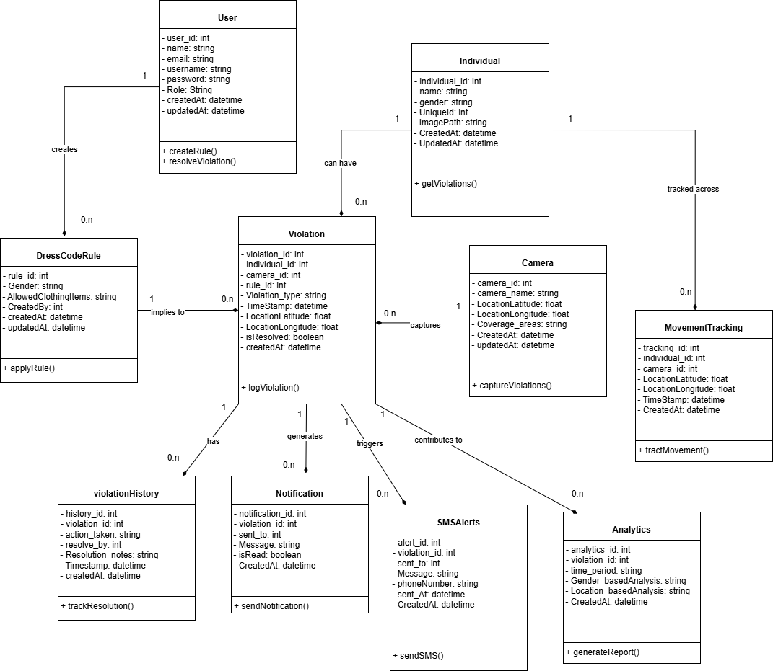

Sequence / Collaboration Diagram
The Sequence Diagram illustrates the dynamic behavior of the Code Watch system, mapping out how the various system components, AI models, and actors interact sequentially over time. The diagram is divided into six critical operational frames that describe the end-to-end lifecycle of a surveillance event.

Lifelines (Participants):
The sequence involves the Admin, the physical Camera, the Detection Model (YOLO), the Facial Recognition Model (FaceNet), the core System backend, the DataBase, the Dashboard frontend, the Student/Employee (violator), and the Analytics module.

Operational Frames:
- Detection And Identification: The process begins with the Camera capturing the live feed and sending it to the Detection Model. The model detects individuals and sends the detection data to the central System. The System then triggers the Facial Recognition Model, which fetches individual details from the DataBase, performs the recognition, and returns the verified identity back to the System.
- Dress Code Compliance: The System commands the Detection Model to analyze clothing attributes. Concurrently, the System fetches the active dress code rules from the DataBase and compares them against the detected attributes.
- Alternative Block (Violation): If a violation is detected, the System calculates the violator's location coordinates and maps their position to the campus. It then dispatches an automated Email/SMS to the Student/Employee. Finally, it notifies the Dashboard, sending the violator's details, including live video, name, gender, and ID.
- Movement Visualization: This frame executes a continuous loop as long as the violation remains active (While Violation True). The System tracks the violator's movement path, updates their coordinates, and continuously sends the visual movement path (complete with directional arrows) to the Dashboard for live tracking.
- Notifications: Upon detecting a violation, the System triggers a notification to the Dashboard and simultaneously logs the violation and individual details into the DataBase. The Dashboard then displays the alert with the violator's details to the Admin.
- Analytics and Reporting: When an Admin requests an analytics report via the Dashboard, the Dashboard queries historical violation data from the DataBase. The DataBase returns this data to the Analytics engine, which generates visual metrics (heatmaps, bar charts, line graphs) and sends them back to the Dashboard to be displayed to the Admin.
- Violation History: The Admin requests to view the violation history through the Dashboard. The Dashboard fetches this history directly from the DataBase and displays the historical logs to the Admin.

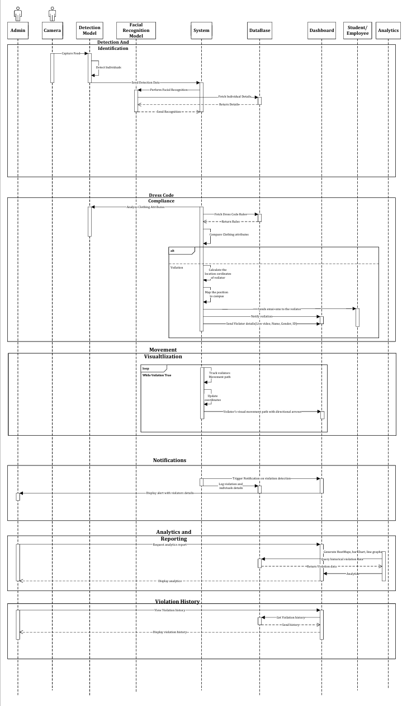

Chapter 5

Implementation

Chapter 5: Implementation
This chapter focuses on the implementation phase of the Dress Code Analytics System, detailing flow control, pseudocode, key components, libraries, deployment environment, tools, and best practices used to develop and deploy the system. This phase translates the system design into a functional and scalable application that automates dress code compliance monitoring, real-time tracking, and alerts.

Important Flow Control/Pseudo codes

5.1.1. User Authentication Flow
BEGIN
PROMPT "Enter Username and Password"
GET username, password
IF check_authentication(username, password) is TRUE THEN
REDIRECT to Admin Dashboard
ELSE
DISPLAY "Authentication Failed"
PROMPT "Enter Username and Password"
ENDIF
END

5.1.2. User Registration Flow
BEGIN
PROMPT "Enter Username, Email, and Password"
GET username, email, password
CHECK if username and email are unique
IF unique THEN
PROMPT "Upload a clear photo for face authentication"
GET photo
PROCESS photo through Face Recognition Model
IF face is unique and recognized THEN
CREATE user account
STORE face biometric data securely
SEND verification email
DISPLAY "Registration Successful. Please verify your email."
ELSE
DISPLAY "Face authentication failed. Ensure a clear photo."
ENDIF
ELSE
DISPLAY "Username or Email already exists."
ENDIF
END

5.1.3. Dress Code Violation Detection Flow
BEGIN
WHILE camera feed is active DO
CAPTURE real-time image of individuals
PROCESS image using YOLO Model
DETECT clothing type and color
CHECK against predefined dress code rules
IF violation detected THEN
LOG violation with timestamp and location
NOTIFY security personnel in real time
ENDIF
END WHILE
END

5.1.4. Real-Time Notifications Flow
BEGIN
IF violation detected THEN
TRIGGER notification to administrators
IF repeat offender THEN
ESCALATE priority of notification
ENDIF
SEND email/SMS to violator (if registered)
ENDIF
END

5.1.5. Movement Tracking Flow
BEGIN
WHILE individual is in frame DO
TRACK movement across multiple cameras
UPDATE real-time location on the map
LOG movement path for historical analysis
END WHILE
END

Components, Libraries, Web Services and stubs

5.2.1. Django Framework
- Used for backend development, handling database management, API services, and security.
- Provides built-in authentication and authorization mechanisms.

5.2.2. Django Templates
- Used for admin dashboard rendering, displaying violations, user profiles, and reports.
- Allows seamless integration of backend data with frontend UI.

5.2.3. Machine Learning (YOLO & OpenCV)
- YOLO (You Only Look Once): Used for real-time dress code violation detection.
- OpenCV: Used for tracking individuals' movements across multiple cameras.

5.2.4. PostgreSQL Database
- Stores user details, dress code violations, tracking logs, and notifications.
- Optimized for handling large-scale image and video processing data.

5.2.5. RESTful API Services
- Developed using Django REST Framework (DRF).
- Provides endpoints for user authentication, violation logs, and tracking data.

5.2.6. Dataset
- Custom dataset trained using YOLOv8 on labeled images of different clothing types and colors.
- Integrated with OpenCV for real-time object detection and tracking.

Deployment Environment

5.3.1. Docker
- Containerizes the application for cross-platform deployment.
- Ensures a consistent development and production environment.

5.3.2. CI/CD (Continuous Integration & Deployment)
- GitHub Actions: Automates testing and deployment pipelines.
- Jenkins/GitLab CI: Ensures smooth integration of new updates.

5.3.3. Configuration Management
- Ansible used for automating server configuration and deployment.

Tools and Techniques
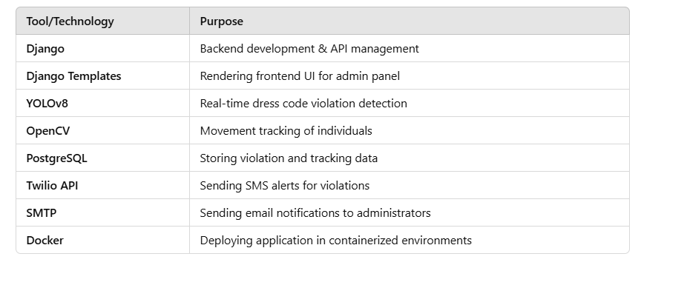

Best Practices / Coding Standards

5.5.1. Code Format

Django & Python (Backend Development)
- Follow PEP 8 coding standards.
- Use docstrings for function descriptions.
- Maintain modular and reusable code structure.

Django Templates & JavaScript (Frontend Development)
- Use consistent indentation and naming conventions.
- Keep frontend responsive and lightweight.

Version Control

5.6.1. Git-Based Version Control
- Uses Git for tracking development changes.
- GitHub/GitLab for remote repository management.

5.7.2. Branching Strategy

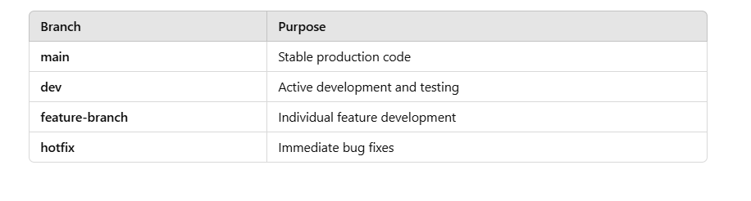

Chapter 6

Testing and Evaluation

Chapter 6: Testing and Evaluation
This chapter details the testing methodologies employed to verify and validate the Code Watch automated surveillance system. Given the real-time, security-critical nature of the application, rigorous testing was conducted across the AI processing pipeline, the Django backend, and the React frontend to ensure high accuracy, low latency, and system stability.

Use Case Testing
Use case testing was performed to validate that the system executes the specific scenarios defined in Chapter 3.
- Detect Individuals & Verify Identity: Video feeds containing registered users were fed into the system to verify that the FaceNet model successfully recognized them and logged their attendance without throwing exceptions.
- Notify Administrators: Simulated dress code violations were injected into the pipeline to verify that the WebSocket connection successfully pushed real-time alerts to the React dashboard.

Equivalence partitioning
Equivalence partitioning was used to reduce the number of test cases by dividing input data into valid and invalid partitions.
- AI Confidence Scores: The object detection (YOLO) confidence thresholds were partitioned. Inputs below the minimum threshold (e.g., < 60%) were tested to ensure they were correctly ignored (invalid class), while inputs above the threshold (≥ 60%) were tested to ensure they triggered the violation logic (valid class).
- User Registration: Uploaded reference images for facial embeddings were partitioned into supported formats (JPG, PNG) and unsupported formats (PDF, GIF) to test the backend's validation logic.

Boundary value analysis
Boundary value analysis focused on testing the extreme edges of the input domains.
- Confidence Thresholds: If the system requires a 75% confidence match for facial recognition, tests were conducted at exactly 74.9%, 75.0%, and 75.1% to ensure the logic handles edge cases precisely.
- Video Feed Framerates: The AI pipeline was tested at the absolute minimum acceptable boundary (15 FPS) and maximum camera output (e.g., 60 FPS) to ensure frames were not dropped or processed out of sequence.

Data flow testing
Data flow testing was utilized to track the lifecycle of critical variables and data structures through the system's architecture. The primary focus was the "Violation Payload" data flow: tracking a captured video frame as it is processed by the AI models, converted into a ViolationLog object in the Django database, and finally serialized into JSON for the React frontend alert system.

Unit testing
Unit testing involved isolating and testing individual components of the Code Watch system to verify their internal logic.
- Backend: Python unittest was used to verify individual Django REST API endpoints (e.g., ensuring a GET request to /api/violations returns a 200 OK status and the correct JSON structure).
- AI Pipeline: Isolated tests were run on the bounding-box drawing functions and the clothing attribute classification functions to ensure they returned expected data structures independent of the live camera feed.

Integration testing
Integration testing evaluated how well the decoupled modules interacted with one another.
- Database Integration: Verified that the Django ORM correctly wrote and retrieved complex relationships (e.g., linking a MovementTracking log to a specific Individual and Camera).
- Frontend-Backend Integration: Tested the connection between the React dashboard and the Django backend, specifically ensuring that HTTP requests and WebSocket connections authenticated correctly using JWT (JSON Web Tokens).

Performance testing
Performance testing measured the system's responsiveness and processing speed under normal conditions.
- Inference Latency: Measured the time taken for the AI pipeline to process a single frame, run both YOLO and FaceNet models, and return a result. The target was to maintain processing times suitable for real-time tracking (under 60 milliseconds per frame).
- Alert Latency: Measured the delay between a violation occurring in the camera feed and the alert appearing on the administrator's dashboard (target: < 2 seconds).

Stress Testing
Stress testing pushed the Code Watch system beyond its normal operational capacity to determine its breaking point and evaluate its failure modes.
- Concurrent Streams: The system was loaded with multiple, simultaneous high-definition RTSP camera feeds to observe GPU memory consumption and CPU utilization.
- Database Load: The system was subjected to simulated environments where dozens of unknown individuals and violations were generated simultaneously to test database write-locking and WebSocket message queue bottlenecks.

Chapter 7

Summary, Conclusion and Future Enhancements

Chapter 7: Summary, Conclusion & Future Enhancements

Project Summary
The Code Watch project was developed to address the critical need for intelligent, automated security and management solutions within modern organizational environments. Transitioning away from traditional, manual video surveillance, this project successfully delivered an active, AI-driven monitoring system. Built on a decoupled architecture, the system utilizes a React.js frontend dashboard and a robust Python/Django backend. By integrating advanced computer vision models—specifically FaceNet for biometric facial recognition and YOLO for object and apparel detection—Code Watch automates essential tasks. These include secure attendance logging, the immediate identification and tracking of unknown or unauthorized individuals, and continuous dress code compliance monitoring, all supported by real-time WebSocket and push notifications.

Achievements and Improvements
The implementation of Code Watch yielded several significant technical achievements and operational improvements over traditional systems:
- Real-Time Automated Processing: Successfully integrated deep learning models (YOLO and FaceNet) to process live RTSP camera feeds, shifting security from a reactive review process to proactive, real-time threat detection.
- Decoupled Full-Stack Architecture: Achieved a highly scalable system design by separating the AI processing and backend routing (Django) from the user interface (React), allowing for independent scaling and maintenance.
- Instantaneous Alerting: Implemented a low-latency notification pipeline using WebSockets, ensuring that administrators receive immediate alerts with snapshot evidence the moment a violation occurs.
- Automated Tracking & Analytics: Eliminated manual log-keeping by automating the generation of violation histories, movement tracking paths, and attendance records, making data readily available for dashboard analytics.

Critical Review
While Code Watch successfully meets its primary objectives, a critical evaluation highlights certain limitations inherent to AI-based surveillance. The accuracy of the facial recognition and dress code monitoring models is highly dependent on environmental factors; poor lighting, severe camera angles, or physical occlusions (e.g., sunglasses, heavy masks) can degrade confidence scores and lead to false negatives. Furthermore, the system is computationally intensive. Processing high-resolution, high-framerate video through multiple neural networks concurrently requires substantial GPU resources. Without adequate hardware acceleration on the application server, the system may experience increased inference latency, potentially delaying real-time alerts.

Lessons Learnt
Developing Code Watch as a solo full-stack and AI project provided profound technical and project management insights.
- System Integration: A major learning curve involved seamlessly bridging the gap between raw data science (AI model inference) and web development (delivering those inferences via REST APIs and WebSockets to a web client).
- Performance Optimization: Processing video frames sequentially can create severe bottlenecks. Learning to optimize the OpenCV frame extraction loop and manage asynchronous tasks was critical to maintaining a playable framerate.
- Database Design for Dynamic Tracking: Designing the schema to handle both known users and temporary, unknown entities (using tracking UUIDs) taught valuable lessons in relational database flexibility and movement logging.

Future Enhancements/Recommendations
To further expand the capabilities and reliability of the Code Watch system, the following enhancements are recommended for future iterations:
- Edge Computing Deployment: To alleviate the heavy computational load on the central server, initial AI inference (such as face detection and cropping) could be shifted directly to edge devices or smart cameras.
- Multi-Camera Person Re-Identification (Re-ID): Enhancing the movement tracking module with specialized Re-ID algorithms to track unknown individuals seamlessly across multiple, non-overlapping camera feeds based on clothing and physical attributes.
- Physical Access Control Integration: Expanding the backend APIs to interface directly with physical security hardware (e.g., smart turnstiles or magnetic door locks), automatically granting access based on positive FaceNet verification.
- Advanced Behavioral Analysis: Training additional AI models to recognize specific actions or anomalous behaviors, such as running in restricted zones, loitering, or physical altercations, moving beyond static object detection.

Appendices

Appendix A: User Manual
This appendix provides a comprehensive user manual for the Code Watch administrative web dashboard. It is designed to guide security personnel, administrators, and directors through the system's primary features, from initial secure login to advanced analytics review. The manual outlines step-by-step instructions for navigating the interface, managing registered individuals, acknowledging real-time alerts, and generating compliance reports. By following these guidelines, authorized users can effectively utilize the system's AI-driven surveillance tools to maintain campus security, track movement, and effortlessly enforce organizational dress code policies.

  - System Access and Navigation
Accessing the Code Watch system requires authorized credentials provided by the chief system administrator. The React-based web dashboard serves as the central command hub for all security operations, providing a responsive interface for real-time monitoring and historical data retrieval.

    - Logging into the Dashboard
To access the platform, navigate to the designated deployment URL using a modern web browser (e.g., Google Chrome, Microsoft Edge). Enter your registered username and password in the secure authentication portal. The system will verify your assigned role (Admin, Director, or SSD) and redirect you to the corresponding customized landing page.

      - Password Recovery
If you misplace or forget your login credentials, click the "Forgot Password" link located at the bottom of the login screen. Follow the on-screen email verification prompts to securely reset your access password without compromising your account's role-based permissions.
  - Managing Violations and Alerts
The core operational functionality of the dashboard involves monitoring, reviewing, and responding to real-time security incidents flagged by the backend AI processing pipeline.
A.2.1. Reviewing Real-Time Alerts
When the system detects a dress code violation or identifies an unknown intruder via the camera feeds, a high-priority notification will immediately appear on the screen. Click directly on the alert notification to open the detailed incident view, which displays the captured snapshot evidence, the exact timestamp, the camera location, and the violator's tracked movement path.
A.2.1.1. Resolving an Incident
After thoroughly reviewing the incident details and the visual evidence, administrators must update the status of the violation log. Use the action dropdown menu to select "Acknowledge," "Resolve," or mark it as a "False Positive." Submitting this status update closes the active alert and updates the centralized security audit trail for future analytics reporting.

Appendix B: Administrator Manual
This appendix serves as the comprehensive technical guide for high-level system administrators tasked with configuring and maintaining the Code Watch application. It covers essential backend operations, including the integration of new IP cameras into the network, the management of the biometric database for facial recognition, and the dynamic configuration of organizational dress code policies. By adhering to these procedures, technical staff can ensure the AI processing pipeline operates with maximum accuracy, minimal latency, and full compliance with organizational security protocols.

  - System and Hardware Configuration
The foundation of the Code Watch surveillance system relies on properly configured hardware inputs and robust administrative controls. This section outlines the procedures for securely linking physical security hardware to the central Django backend.

    - Camera Network Integration
To enable the AI pipeline to monitor a specific physical area, administrators must register the physical IP cameras into the system database. The application is designed to ingest standard RTSP (Real-Time Streaming Protocol) feeds directly from standalone network cameras or existing Video Management Systems (VMS).

      - Registering an RTSP Stream
Navigate to the 'Camera Management' module on the administrative dashboard. Select the 'Add New Camera' action button to open the configuration form. You must input a recognizable camera name, its geographical location coordinates (latitude and longitude), and the active RTSP URL. Ensure that the host network firewall is configured to allow the backend server to pull the video stream via the specified RTSP port before saving the configuration.

  - Biometric and Policy Management
Maintaining an accurate and up-to-date database is critical for the efficacy of the AI models. Administrators must carefully manage the biometric profiles used by the FaceNet recognition model and the active compliance rules enforced by the YOLO object detection model.

B.2.1. Personnel Profile Management
The system requires high-quality baseline data to accurately recognize registered staff, students, and faculty. Administrators hold the exclusive privilege to create, update, or deactivate these personnel profiles through the 'User Management' portal to prevent unauthorized database manipulation.
B.2.1.1. Uploading Reference Images
When registering a new individual in the system, the administrator must upload a clear, front-facing reference photograph. Upon upload, the backend AI pipeline will process this image to extract a unique facial embedding vector, which is then securely stored in the database. To guarantee high confidence scores during live video detection, ensure the reference image is well-lit, high-resolution, and the subject's face is completely unobstructed.

Appendix C: Information / Promotional Material
This appendix contains the textual content and layout guidelines for the promotional materials designed to showcase the Code Watch project. These materials are intended for presentations, project exhibitions, and departmental showcases to rapidly communicate the system's value proposition, core features, and underlying technology to both technical and non-technical audiences.

  - Broacher

  - Flyer

  - Standee

  - Banner

Appendix D: Developer Setup Guide
This appendix provides the technical instructions required to configure the local development environment for the Code Watch system. It outlines the necessary dependencies, package installations, and environment variables required to run the Django backend, the AI processing pipeline, and the React frontend on a local development machine.

  - Backend System Configuration
The backend of Code Watch relies on Python and the Django REST Framework to manage the database and handle API requests. Proper configuration of the Python environment is critical to ensure compatibility with the deep learning libraries.

Python Environment Setup
Before installing the project dependencies, it is recommended to isolate the project using a virtual environment. This prevents conflicts between the system-wide Python packages and the specific versions required by the Code Watch AI models (such as YOLO and FaceNet).

      - Third level heading [12 pt, Calibri, Bold, Left aligned]
To initialize the environment, open your terminal or command prompt, navigate to the root directory of the backend repository, and execute the standard Python venv command. Once created, activate the environment. With the environment active, run pip install -r requirements.txt to automatically download and install all necessary dependencies, including Django, OpenCV, and PyTorch

  - Frontend System Configuration
The web dashboard is built using React.js. It requires a Node.js runtime environment to manage packages and compile the frontend code for local testing.

React Development Server
Ensure that Node.js and the Node Package Manager (NPM) are installed on your system. Navigate to the frontend directory of the Code Watch repository.

Package Installation and Execution
Run the npm install command to download all frontend dependencies listed in the package.json file. Once the installation is complete, execute npm start to launch the local development server. The React application will automatically compile and open in your default web browser, connecting to the local Django backend API.

Reference and Bibliography

Reference and Bibliography

[1] J. Redmon, S. Divvala, R. Girshick, A. Farhadi, “You Only Look Once: Unified, Real-Time Object Detection” Proceedings of the IEEE Conference on Computer Vision and Pattern Recognition (CVPR), pp. 779-788, IEEE/Las Vegas-USA, 2016.
[2] F. Schroff, D. Kalenichenko, J. Philbin, “FaceNet: A unified embedding for face recognition and clustering” Proceedings of the IEEE Conference on Computer Vision and Pattern Recognition (CVPR), pp. 815-823, IEEE/Boston-USA, 2015.
[3] IEEE Computer Society, “IEEE Recommended Practice for Software Requirements Specifications” IEEE Std 830-1998, pp. 1-40, IEEE/New York-USA, 1998.
[4] I. Sommerville, “Software Engineering” 10th Edition, Pearson/Boston-USA, 2015.
[5] G. Bradski, “The OpenCV Library” Dr. Dobb's Journal of Software Tools, Volume 25, Issue 11, pp. 120-123, CMP Media/San Francisco-USA, 2000.

